 Microbiology Swab Specimen Collection
Investigation | Collection Container/kit | Tests – Refer also to the Pathology Handbook Test & Collection Guide
STIPCR - Chlamydia/Gonorrhoea/Trichomonas vaginalis (CT/NG/TV) | 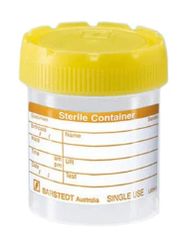  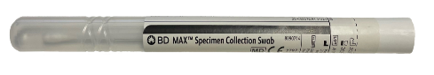 | Females:  - Cervical/Endocervical swab for STIPCR  - First-stream urine (15-20mLs) as alternative/additional test (after not voiding for at least 2 hours).  Males:  - First-stream urine (15-20mLs) is the preferred specimen (after not voiding for at least 2 hours)  Throat swab  Rectal Swab
Herpes PCR  (HSV-1, HSV-2, VZV, CMV, Adenovirus, Enterovirus)  & All other non-respiratory PCR requests (except CT/NG/TV) | 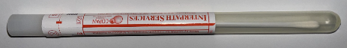 | - White-top dry swab
General wound MCS  Group B Screen (GBS)  CRE/CPO Screen  MRSA Screen  VRE Screen  C.auris Screen  Genital MCS | 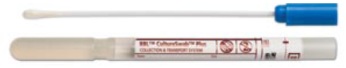 | Open wounds: Clean with a swab moistened with normal sterile saline until red granulation tissue is visible.  Closed wounds: Clean away excess debris and purulent material from the opening.  GBS: Blue-top swab for combined low vaginal and rectal swab. See http://ehpolicies.eh.local:90/index.aspx?itemDetails=2546  CRE: Rectal swab AND separate inguinal swab (Faecal specimen is preferable, rectal swab MUST have visible faeces).  MRSA: Nose & groin swabs, +/- axilla +/- throat  VRE: Rectal swab with visible faeces  C.auris: bilateral axilla and groin swabs  Genital MCS:  - Females - High vaginal swab/Cervical swab. (For Chlamydia/Gonorrhoea/Trichomonas vaginalis PCR see STIPCR section).  - Males – Urethral swab (use orange top charcoal swab – see below)
 | 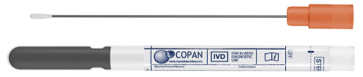 | Gonorrhoea culture or Urethral swab MCS
COVID-19/Influenza A/Influenza B/ RSV PCR  Extended Respiratory PCR including Bordetella pertussis PCR. | 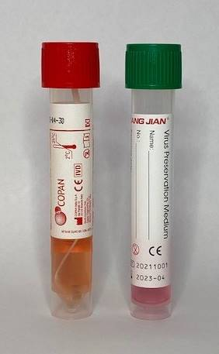 | - Collect a nose & throat swab for COVID19/Influenza A/Influenza B/RSV PCR.  - For Bordetella pertussis PCR - Nasopharyngeal swab is preferred specimen.

General Instructions:

- Label all specimens with
  - Patient’s surname and given name
  - UR no (if available)
  - Date of birth
  - Site of collection and
  - Date/time of collection
- Store swabs for M&C at room temperature prior to transport to the laboratory.
- Chlamydia/ Gonorrhoea/Trichomonas PCR (white-top) swabs and first pass urine specimens MUST be received in an EHP laboratory within 2 hours of collection.

