**Background information**

Faecal Occult Blood Test (FOBT) is a test that can detect tiny traces of blood in the stool (poo)

**Dietary / Medication Advice**

1. For 1 day before and then during the collection period you need to maintain a well-balanced diet which should include fruit, vegetables & cereals
2. Do not collect samples during or until 3 days after a menstrual period.

**Collection Procedure**

1. You will be provided with 3 containers, one for each day.
2. It is suggested that your faeces/stool sample is collected initially into a plastic disposable container (an ice-cream container is ideal). Pass urine into the toilet if necessary.
3. Twist the green cap on the collection container to remove it. Insert the sampling probe into 5 or 6 locations in the faeces.
4. Return the sampling probe into the collection container.
5. Shake the collection container vigorously up & down several times.
6. Dispose the remaining sample down the toilet, wash and prepare the container for the next day’s sample.
7. Label sample with your full name, date of birth, UR number (if available on the request form) or Medicare number and date & time of collection and place in the specimen bag provided. Place the completed sample in the fridge.
8. Repeat all steps for second and third sample collections.
9. Place the completed sample in the fridge after each collection and return to your nearest Eastern Health Pathology collection service (see below). Samples should be received in the laboratory within 1 day of the last collection.

**Pathology Collection**

Angliss Hospital - 9764 6135

Box Hill Hospital - 9895 4905

Healesville Collection Centre - 59699949

Maroondah Hospital - 9871 3572

Yarra Ranges Health - 8706 9665 (Tues & Thurs mornings only)

|  |
| --- |
| PRINTING PERMITTED DATE OF PRINTING: 30/01/2025  Patient Instructions- Faeces for Occult Blood Collection 15/03/2024  WORK-CS-8 Page **1** of **2** |

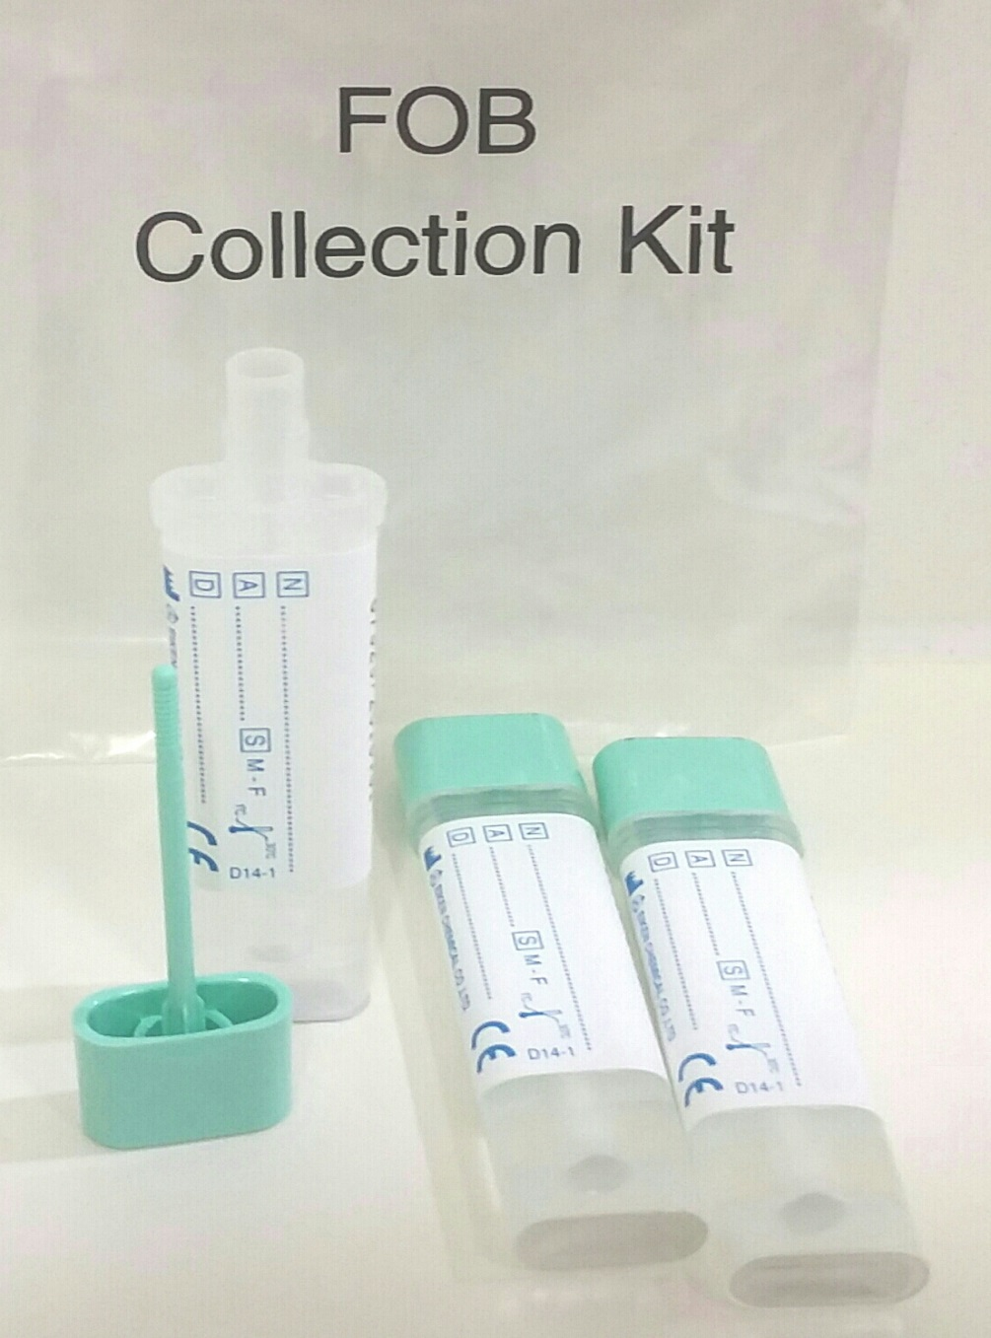

**3**

**2**

**1**

Label each FOB Sample with the following details:-

* Surname and First Name
* Date of birth
* Date and time of sample collection
* Label each container 1, 2 & 3 in order of daily collection
* Place each completed sample into bags provided and place in fridge. Return all 3 samples together on day 3, if possible, or at latest the following day.
* Bring your referral and Medicare card

Stab sample 5 to 6 times. Place stick back into container & shake vigorously

PRINTING PERMITTED DATE OF PRINTING: 30/01/2025

Patient Instructions- Faeces for Occult Blood Collection 15/03/2024

WORK-CS-8 Page **2** of **2**