**COLLECTION GUIDE**

**Background Information**

Your doctor has ordered this test to determine if an infection is present. It includes microscopic examination, culture to isolate and identify any possible pathogens (germs) and the testing of the isolated organism against a number of antibiotics to establish the most effective treatment. It is important to follow the collection instructions carefully in order to obtain a specimen that is free from contamination.

**Female Patients**

**Equipment**

* 3 x Sterile water
* 1 x Sterile collection container
* 1 x Plastic Jar Holder
* 1 x Plastic Biohazard bag
* Gloves, if required

**Specimen Collection**

* Urine pot holder will be provided
* Gloves will be provided upon request.
* Ideally, the patient should straddle the toilet.
* 3 x Sterile wipes will be provided.
* Separate the labia and cleanse area with sterile water wipes from front to back.
* New wipe for each side – Left outer side of labia, right outer side of labia, lastly middle.  
   Wiping from front to back.
* A vaginal tampon is useful if there is a vaginal discharge.
* Prepare jar. Remove lid. To prevent contamination to the jar, do not touch inside.  
  Place jar into the urine jar holder - See diagram on back of your leaflet.
* Commence your (wee) urine flow in the toilet, and while continuing to void (pass urine), place the sterile   
  container in the stream to obtain 10 - 20mL of urine.
* Place/stick your label on to the front of your jar, and return the sample to your collector.
* If you are unable to pass urine at the time of visit. You may take sample jar home and collect first thing in   
  the morning. Ensure the lid has been placed on correctly and lid tightened to prevent leakage.
* Label your sample with your Surname, First Name, Date of birth (Format - xx/xx/xxxx ) , Date and time of   
  collection and your UR Number, if available, or Medicare number.
* Ensure you document date and time sample was collected.
* Place sample into the biohazard bag provided and keep in the refrigerator until you are ready to return it to your closest Eastern Health Pathology collection centre.
* Sample must be fresh. Please deliver as soon as practical from time of collection.   
  .

PRINTING PERMITTED DATE OF PRINTING: 30/01/2025

MSU Collection Guide 15/03/2024

WORK -CS-6 Page 1 of 2

**Male Patients**

**Equipment**

* 1 x Sterile water
* 1 x Sterile collection container
* 1 x Plastic Jar Holder
* 1 x Plastic Biohazard bag

**Specimen Collection**

* The foreskin should be gently retracted and the glans cleaned with sterile water wipes. Do not use soap or disinfectants.
* When urinary stream is established, and while continuing to void, place the sterile container in the stream to obtain 10 - 20mL of urine
* Label sample jar with label provided and return sample to your collector.
* If you are unable to collect sample at time of visit. You may collect your urine (wee) sample from home.
* Ensure you label your jar with your Surname, First name, Date of birth, Date and time sample collected.
* Check the lid has been placed on firmly and securely.
* Place the labelled jar into the biohazard bag provided and keep refrigerated until you are ready to drop sample back to your nearest convenient Eastern Health Pathology Collection Centre.

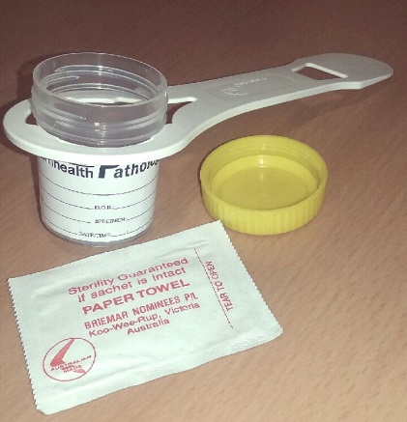 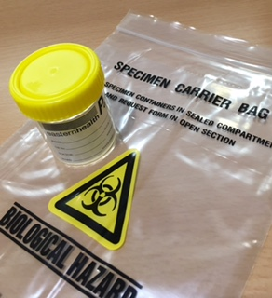

Sterile Jar with holder and wipe Sterile Jar and Biohazard Bag

**Pathology Collection**

Angliss Hospital - 9764 6135

Box Hill Hospital - 9895 4905

Healesville Collection Centre - 5969 9949

Maroondah Hospital - 9871 3572

Yarra Ranges Health - 8706 9665 (Tues & Thurs morning only)

PRINTING PERMITTED DATE OF PRINTING: 30/01/2025

MSU Collection Guide 15/03/2024

WORK -CS-6 Page 2 of 2