**Background Information**

This test is to detect the presence of an infection caused by toxin producing in Clostridium difficile bacteria

**COLLECTION GUIDE**

**Equipment**

1 X White container with brown screw top. Gloves will be provided, if required.

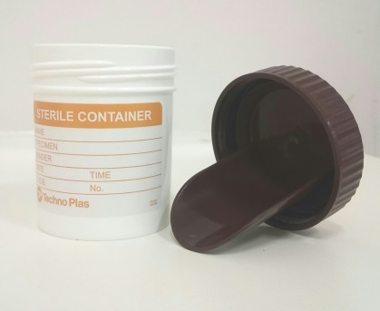 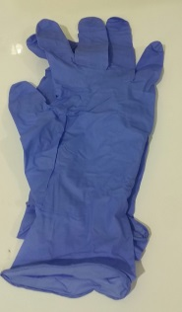

**Specimen Collection**

1. It is suggested that your faeces (poo) sample is collected initially into a plastic disposable container (an ice-cream container is ideal).
2. There is a pooper scooper attached on the inside of the brown lid. Scoop a small portion of your sample, about the size of walnut, and place into the white container.
3. Discard the remainder of your sample in the toilet and dispose of the container and gloves (if used)
4. Ensure lid is tightly sealed.
5. Label the container with your Surname, First Name, Date of Birth, UR number (if available on your request form).  
   It is important to also document on the jar the date and time you collected your sample.
6. Place in specimen bag provided and seal.
7. Place sample in fridge prior to dropping off to your closest Eastern Health Pathology Collection Centre. See list below. It is important to get your sample to us as fresh as possible for testing.

**Pathology Collection**

Angliss Hospital - 9764 6135

Box Hill Hospital - 9895 4905

Healesville Collection Centre - 5969 9949

Maroondah Hospital - 9871 3572

Yarra Ranges Health - 8706 9665

PRINTED COPY PERMITTED DATE OF PRINTING : 30/01/2025

Faeces C.difficile toxin Collection Guide Date: 16/12/2024

WORK-CS-31 Page 1 of 1