**Background Information**

Faeces, or stool (poo) sample helps the doctor to determine the health of your bowel and rule out any infections.

**Equipment**

1. **Culture and/or Parasites -** 1 Brown topped specimen pot

**Specimen Collection**

**Note:** Specimen pots have a scoop attached to the lids for collection of faeces.

**Your doctor may have requested for multiple samples (2 or 3) to rule out parasite infection. If this is the case, collect the 2 or 3 specimens on separate days, within a 7-day period.**

1. **Label the specimen pot with your full name, date of birth, UR number** (if available on the referral), or Medicare number, and time and date of collection.
2. It is suggested that your faeces (poo) sample is collected first into a plastic disposable container (an ice-cream container is ideal).
3. Using scoop collect a small amount of faeces (about the size of 20c piece) and place into brown top pot. Secure lid.
4. Ensure lids are tightly sealed. Place brown top pot in specimen bag and seal. **Don’t forget to label the container with your details or the lab cannot process it.**
5. Discard any remaining specimen in the toilet and dispose of the container.
6. Take samples to the collection centre (see list of centres below) as soon as possible, the fresher the sample the better. Sample should arrive to the lab on the same day it was collected

**Pathology Collection**

Angliss Hospital - 9764 6493/6135

Box Hill Hospital - 9895 4905

Healesville Hospital - 5969 9949

Maroondah Hospital - 9871 3579/3572

Yarra Ranges Health - 8706 9665 (Tues & Thurs mornings only)

PRINTED COPY PERMITTED DATE OF PRINTING : 30/01/2025

Faeces M&C /Parasites Patient Instructions Date: 26/03/2024

WORK-CS-29 Page 1 of 2

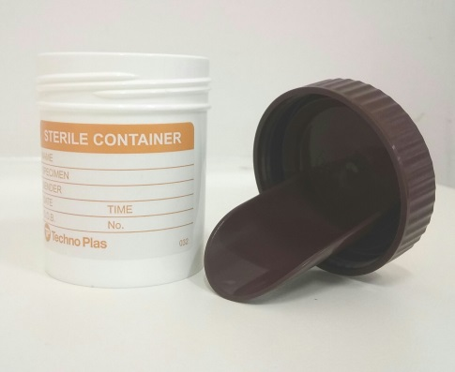 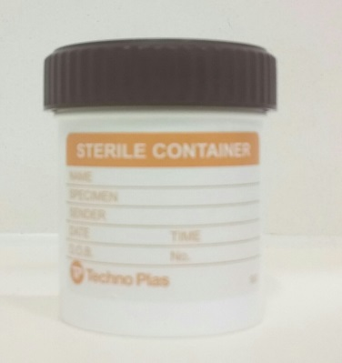

Use the pooper scooper attached to the inside lid of your jar.

Collect a walnut size of sample

Place sample into the white jar and secure lid. Ensure it is placed on tight.

Label jar with Surname, first name, date of birth and date/time sample collected.

PRINTED COPY PERMITTED DATE OF PRINTING : 30/01/2025

Faeces M&C Patient Collection Services Guide Date: 26/03/2024

WORK-CS-29 Page 2 of 2