**First Pass Urine:** Instruct patient to collect the first 20-30mLs in the jar.

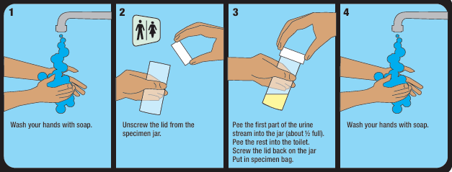

**Throat swab:** Run swab across tonsils and back of oropharynx.

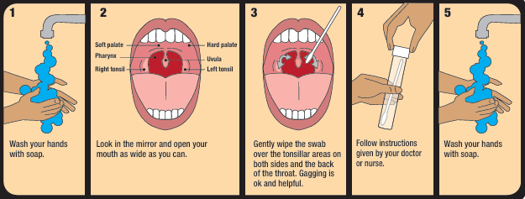

**Rectal swab:** Instruct patient to insert the swab about 3cm into the anus.

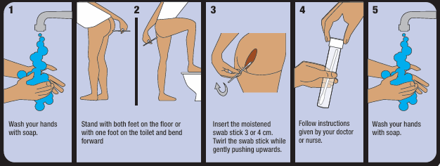

(Images taken from NSW Health STI Programs Unit: [Swab-Self-Collection-Chart-2020.pdf (nsw.gov.au)](https://pro.playsafe.health.nsw.gov.au/wp-content/uploads/2024/09/Swab-Self-Collection-Chart-2020.pdf)