CSF SPECIMEN INFORMATION – LABORATORY PROCESSING
Depending on the tests requested, 3-4 separate tubes will need to be provided. Note that the tubes are numbered so that order of collection can be identified – this order should be carefully followed, so that the optimal sample can be used for the requested tests. It is also important to consider the tests that are required, as this will determine how much CSF is needed in each tube. See the matrix below for details.
TUBE 1 is used for Cytology.
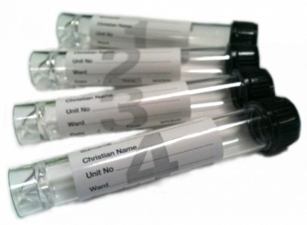
TUBE 2 is used for Glucose, Protein and Flow Cytometry.
(centrifuged in the lab – the supernatant is used for Biochemistry analysis (glucose, protein) and the cellular pellet will be used for flow cytometry if required).
TUBE 3 is for Microbiological analysis (cell count, Gram stain and culture) and any further infectious testing (e.g. viral PCR, mycobacterial PCR and culture, cryptococcal antigen).
TUBE 4 will be required only for;
(a) Creutzfeld-Jacob Disease (CJD) testing OR
(b) Xanthochromia analysis (wrap the tube in foil to prevent sample deterioration due to light).

TESTS REQUIRED | MINIMUM REQUIRED VOLUME (mL)
 | TUBE 1 | TUBE 2 | TUBE 3 | TUBE 4
CYTOLOGY. CHEMISTRY, MICRO/CULTURE | 1.0-2.0 | 1.0 | 1.0-2.0 | Nil
ADD FLOW CYTOMETRY |  | add 5.0-7.0
ADD OTHER INFECTIOUS MARKERS |  |  | add 2.0- 5.0-
ADD MYCOBACTERIAL CULTURE |  |  | Add 10.00
ADD CJD |  |  |  | 1.0
ADD XANTHOCHROMIA |  |  |  | 1.0 (foil)

Note, the ability to add further tests to a previously collected sample is dependent upon the volume provided. Also, many tests (flow cytometry, cytology) can only be performed on fresh specimens.

Other specialised testing (e.g. oligoclonal bands) will be performed using the supplied samples.

Xanthochromia and CJD analysis cannot be performed on a blood-stained sample.

