**What is the bone marrow, and what does a bone marrow biopsy involve?**

**The bone marrow** is the spongy and liquid matter in large bones, responsible for the making of normal red blood cells (carry oxygen), white blood cells (fight infections) and platelets (assist with blood clotting).

**A bone marrow biopsy** is the process where both the liquid marrow (the aspirate) and a piece of solid bone (trephine) are removed (usually from the back of the hip bone). Both liquid and solid marrow are then examined under the microscope and tested in other ways.

**Purpose**

There are many reasons why a bone marrow biopsy is requested. The main ones are:

1. **For diagnosis** of a bone marrow disease, prompted by abnormal blood tests you may have had.
2. To **determine the extent of spread** of diseases such as lymphoma that has already been diagnosed on a biopsy at another site (for staging).
3. To **assess the response** of a disease to therapy (e.g. for acute leukaemia after chemotherapy).

**What does the bone marrow biopsy involve?**

A bone marrow biopsy is a day procedure that is often performed in Day Oncology (4.3) with a sedative. You will be asked to lie on your side, curled up with your knees toward your chest. A nurse will usually administer a sedative, and your breathing rate and oxygen levels will be monitored.

Most bone marrow biopsies are obtained from the pelvic (hip) bone and are performed by a trained doctor. The skin of the site of the biopsy will be cleaned, made numb with a local anaesthetic. The doctor will make a small incision in the skin and insert the bone marrow needle. A needle will be used to take a sample of your bone marrow and a small piece of the bone.  A waterproof dressing will be applied to the site of the biopsy. You will then be required to lie flat for an hour, after which you may go home if there are no complications.

**For 24 hours after receiving intravenous sedation, you are not to drive, nor operate any machinery requiring careful attention, as your reaction time and reflexes are likely to be slower than normal. It is also suggested that you do not make legal decisions/sign any legal documents in that time period.**

**What preparations are required for the bone marrow biopsy?**

**You are required to fast (no solid food) for at least 6 hours and clear fluids up to 2 hours prior to the biopsy. However, medications with a sip of water are allowed.**

If you are on medications that thin the blood (warfarin, dabigatran (Pradaxa), rivaroxaban (Xarelto), apixaban (Eliquis); aspirin, clopidogrel, prasugrel etc), or diabetic medications, please inform the medical staff beforehand. The laboratory haematology registrar can be contacted 48hours prior to the procedure to discuss any omission of doses that may be required. Contact number is 9895 3486 during working hours Monday to Friday.

Please make arrangements for your transportation to and from the hospital. Somebody else will need to drive you home.

PRINTING PERMITTED DATE OF PRINTING:

Bone Marrow Biopsy Date: 16/03/2017

WORK-PA-1 Page 1 of 2

**What can I expect after a bone marrow biopsy?**

You will have a dressing placed on your back at the site of the biopsy. Please keep the dressing dry for the first 24 hours, and the dressing on for 3 days.

Serious complications from bone marrow biopsies are rare. The most common complication is bleeding. It is very rare that bleeding will require medical intervention however, a slight ooze after the procedure may occur. There will be some discomfort for the first few days after the biopsy at the site of the procedure. This is normal, and should improve with time. Simple analgesia such as paracetamol should suffice. Infection is very rare, and in previous cases, have responded well to antibiotic treatment.

In case of any concerns, please contact the Laboratory Haematology Registrar on 9895 3486 for more information.

Map of Box Hill hospital (Building A). Day Oncology is Ward 4.3 on level 4 (use the main lifts from the carpark or behind reception at street level (item “L” on map of building A, below). Please report to the Level 4 reception desk (4.2).

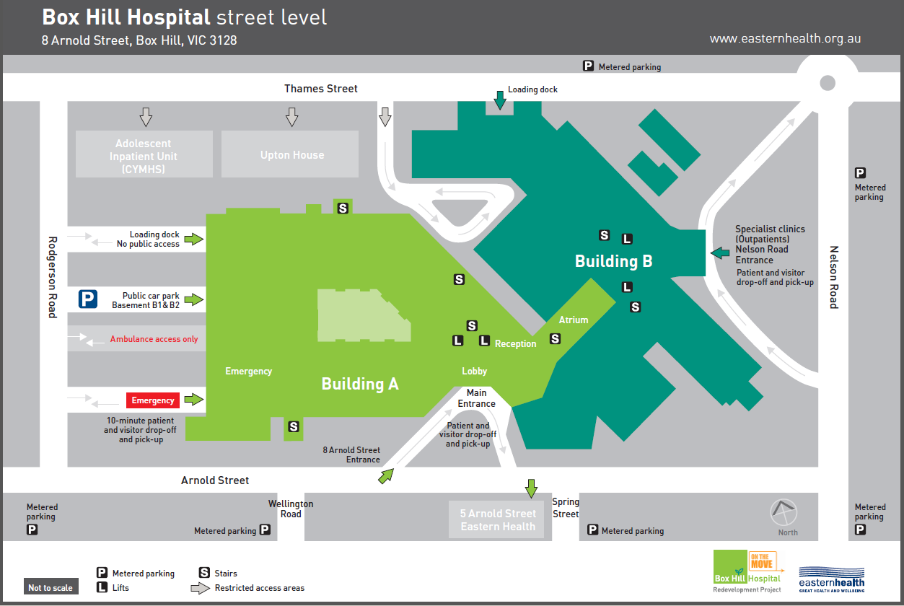

**Checklist**

1. **Arrange transportation.**
2. **Inform doctor about medications (especially blood thinners and diabetic medications) and allergies.**
3. **Fast (6 hours for solids, clear fluids until 2 hours prior to procedure, medications permissible).**
4. **Wound and dressing care – dry for 24 hours, in place for 3 days.**
5. **Contact number (9975 6435 or 9895 3486): contact if any concerns**.

**Your appointment details**

**When you arrive please go to the reception desk Building A, Level 4.2**

**DATE: ___________________________________________**

**TIME: ___________________________________________**

**Protecting Your Privacy**

Eastern Health is committed to protecting your privacy. We will keep your personal information secure and will disclose information about you only when required by law. We comply with relevant information and privacy legislation. If you would like more information, please ask a staff member or visit our Web site [www.easternhealth.org.au](http://www.easternhealth.org.au/)

Eastern Health is accredited by the Australian Council on Healthcare Standards.

5 Arnold Street, Box Hill, Victoria 3128

1300 342 255

**© Eastern Health 2014**

PRINTING PERMITTED DATE OF PRINTING:

Bone Marrow Biopsy Date: 16/03/2017

WORK-PA-1 Page 2 of 2