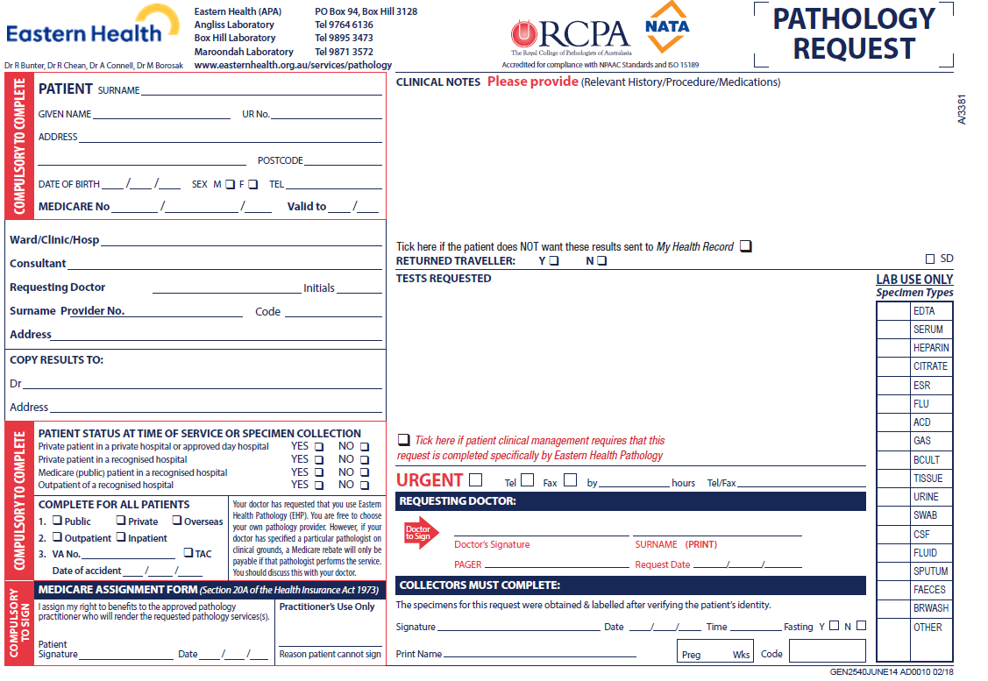

**Warfarin Dosing Questionnaire**

Rule 3 Exemption DINR (dosing INR) Original Request Date: __________________________

Patient Contact Telephone Number: ___________________ Alternative Contact No.: ________________________

Was the last INR performed at another site or Laboratory? Yes ⃝ or No ⃝ (tick applicable). If yes,   
 Where / When: _________________________________________________________________________________

What is the current does of Warfarin? State current dose __________ mg.

Any changes in medication since the last test? Yes ⃝ or No ⃝ (tick applicable).   
 E.g.: aspirin, laxatives, antibiotics, vitamin/dietary supplements? If yes, please list:   
 ______________________________________________________________________________________________

Any recent or current illness or hospitalisation? _______________________________________________________

Any recent bleeding, bruising or blood in urine? _______________________________________________________

Any missed Warfarin tablets recently? _______________ Any major changes in diet? _______________________  
   
 Any comments and/or further information? E.g. Pending travel plan OR upcoming surgery?

______________________________________________________________________________________________