SPECIMEN collection for CPE Screening

On admission, these patients will require a single room, standard and enteric precautions and CPE screening:
- Direct transfer from an overseas hospital (screening specimens taken > 7 days after the most recent contact with an overseas facility)
- Overnight stay in an overseas healthcare or long-term residential care facility in the previous 12 months (screening specimens taken > 7 days after the most recent contact with an overseas facility)
- A room contact of a CPE case who has not achieved clearance criteria
  - A ward contact of a CPE case where transmission has occurred.

Patients should be consented prior to screening and offered written information (Objectify – Management of CPE. Appendix 4: Screening for CPE – Information for patients).

- Preferred option – fresh faecal specimen
Please ensure specimens are marked URGENT are transported promptly to the laboratory for processing.

- Second line option (if unable to obtain faecal specimen in safe or timely fashion)
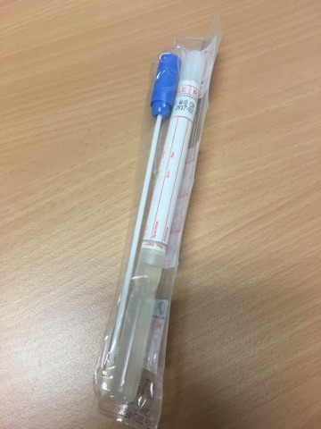 | AND
Collect a rectal swab using the transport media swab. There should be faecal matter on the swab or sample will be rejected by laboratory |  | Collect an inguinal (groin) swab using the transport media swab

Please contact IPAC team for your site if you have any questions

