MINIMUM LABELLING REQUIREMENTS

To comply with NSQHS Standards, as of October 1st, 2012 Pathology request forms AND specimens MUST have 3 identifiers:

- Patient’s Full NAME- i.e. Surname AND Given name
- DOB (Date of Birth)
- UR Number OR For Outpatients Patient’s full Address or Medicare #
NO LABEL/INCOMPLETE LABEL = NO TESTING
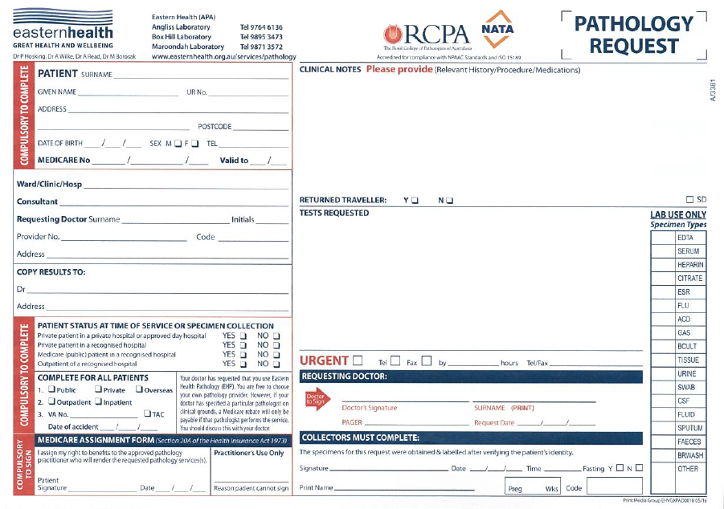
CLINICAL DETAILS – Required for all requests:
Include: Current problem/ Differential diagnosis/ Relevant medical history
This information will assist with determining the level of investigation required and the importance and prioritisation of unexpected results.

CONTACT DETAILS – Required for all requests:
Legible referrer name and contact and/or after hours contact and Pager/ Phone number must be supplied on EACH REQUEST
This information is required for effective communication of critical results.

SPECIMEN RELABELLING NOT PERMITTED

NATA Accreditation requirements reflect a tight policy on specimen relabelling.**
From October 1st, 2012 re-labelling of specimens has not been permitted.

Pathology will not accept:
- UNLABELLED SPECIMENS
- MIS-LABELLED SPECIMENS
- INSUFFICIENTLY LABELLED SPECIMENS
Compliance will ensure maximum patient safety is a priority.
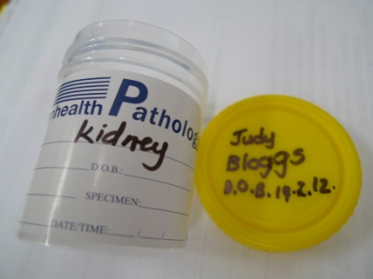

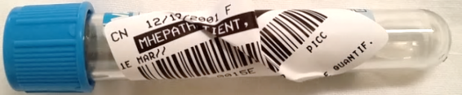

INCORRECT XX

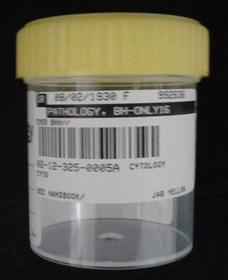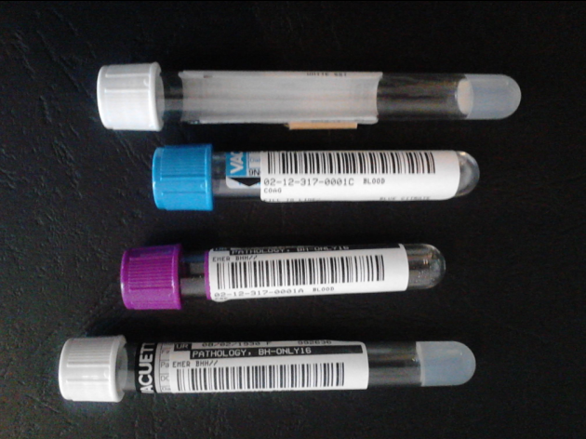
CORRECT

For further information please refer to:

- Eastern Health Objectify Policy 81: Specimen Minimum Labelling Requirements
- Pathology On-Line Handbook

**NATA/ ISO 15189 Medical Testing Field Application Document July 2012

QUESTIONS:
If you have any questions or require further information on any of these initiatives please contact Pauline McGrath, Pathology Director of Operations, on 9895 3145 or Janet Steele ADQPI, Pathology on 9895 3565.

